AKASH PATEL  
8659076  
ASSIGNMENT 4

SENG8040

**Testing Methodologies**

**__________________________________________________________**

**Assignment #4: Rubric**

|  |  |  |  |
| --- | --- | --- | --- |
| **#** | **Mark** | **Weight** | **Criteria** |
|  |  |  | **Part 1: Decision Table** |
| **1.** |  | 6 | All conditions and actions identified in the full decision table |
| **2.** |  | 3 | Correct "don't cares" identified in second decision table |
| **3.** |  | 3 | All redundancies removed in final decision table |
| **4.** |  | 8 | Correct test cases derived from final decision table |
|  |  |  | **Part 2, Task 1: Web Application** |
| **5.** |  | 3 | Form input fields are validated properly |
| **6.** |  | 3 | Data input is saved |
| **7.** |  | 3 | After saving, information entered is displayed, including link to the correct JD Power and Associates page |
| **8.** |  | 3 | Page created to display a list of previously saved data |
|  |  |  | **Part 2, Task 2: System Tests** |
| **9.** |  | 8 | System test 1 works and is unique compared to the other system tests |
| **10.** |  | 8 | System test 2 works and is unique compared to the other system tests |
| **11.** |  | 8 | System test 3 works and is unique compared to the other system tests |
| **12.** |  | 8 | System test 4 works and is unique compared to the other system tests |
| **13.** |  | 8 | System test 5 works and is unique compared to the other system tests |
|  |  |  | **Version Control** |
| **14.** |  | 3 | Screenshot showing repository with a commit history. |
|  |  | -0.5 per | **Programming standards deductions (i.e. spelling mistakes, naming, etc.).** |
|  |  | -15 | **Failure to present or not ready when asked deduction.** |
|  |  | -15 | **Late submission (per day)** |
|  |  | -7.5 | **Hard copy not handed in or not all documents listed handed in (order).** |
|  |  | **75** | **Total Marks** |

**Decision Tables**

|  |  |  |  |  |  |  |  |  |  |  |  |  |  |  |  |  |
| --- | --- | --- | --- | --- | --- | --- | --- | --- | --- | --- | --- | --- | --- | --- | --- | --- |
| Stub |  |  |  |  |  |  |  |  |  |  |  |  |  |  |  |  |
| Accidents - x: greater than 3 y: lesser than 3 | x | x | x | x | x | x | x | x | y | y | y | y | y | y | y | y |
| Driving expirience (x: no expirience, y: one year expirience, z: 2 to 9 years of expirience, w: more than 9) | x | x | y | y | z | z | w | w | x | x | y | y | z | z | w | w |
| Age - x lesser than 30, y greater than or equal to 30 | x | y | x | y | x | y | x | y | x | y | x | y | x | y | x | y |
|  |  |  |  |  |  |  |  |  |  |  |  |  |  |  |  |  |
| Effects |  |  |  |  |  |  |  |  |  |  |  |  |  |  |  |  |
| No insurance | X | X | X | X | X | X | X | X |  |  |  |  |  |  |  |  |
| Base rate 3000 |  |  |  |  |  |  |  |  | X | X |  |  |  |  |  |  |
| Base rate 2000 |  |  |  |  |  |  |  |  |  |  | X | X | X | X |  |  |
| Base rate 1000 |  |  |  |  |  |  |  |  |  |  |  |  |  |  | X | X |
| 20% reduction rate |  |  |  |  |  |  |  |  |  |  |  |  | X |  | X |  |
|  |  |  |  |  |  |  |  |  |  |  |  |  |  |  |  |  |

|  |  |  |  |  |  |  |  |  |  |  |  |  |  |  |  |  |
| --- | --- | --- | --- | --- | --- | --- | --- | --- | --- | --- | --- | --- | --- | --- | --- | --- |
| Stub | **Entry** | | | | | | | | | | | | | | | |
| Accidents - x: greater than 3 y: lesser than 3 | x | x | x | x | x | x | x | x | y | y | y | y | y | y | y | y |
| Driving expirience (x: no expirience, y: one year expirience, z: 2 to 9 years of expirience, w: more than 9) | - | - | - | - | - | - | - | - | x | x | y | y | z | z | w | w |
| Age - x lesser than 30, y greater than or equal to 30 | - | - | - | - | - | - | - | - | - | - | - | - | x | y | x | y |
|  |  |  |  |  |  |  |  |  |  |  |  |  |  |  |  |  |
| Effects |  |  |  |  |  |  |  |  |  |  |  |  |  |  |  |  |
| No insurance | X | X | X | X | X | X | X | X |  |  |  |  |  |  |  |  |
| Base rate 3000 |  |  |  |  |  |  |  |  | X | X |  |  |  |  |  |  |
| Base rate 2000 |  |  |  |  |  |  |  |  |  |  | X | X | X | X |  |  |
| Base rate 1000 |  |  |  |  |  |  |  |  |  |  |  |  |  |  | X | X |
| 20% reduction rate |  |  |  |  |  |  |  |  |  |  |  |  | X |  | X |  |

|  |  |  |  |  |  |  |  |  |  |  |  |  |  |  |  |  |  |
| --- | --- | --- | --- | --- | --- | --- | --- | --- | --- | --- | --- | --- | --- | --- | --- | --- | --- |
| Stub | **Entry** | | | | | | | | | | | | | | | | |
| Accidents - x: greater than 3 y: lesser than 3 | 3 or more than 3 | | | | | | | | Lesser than 3 | | | | | | | | |
| Driving expirience (x: no expirience, y: one year expirience, z: 2 to 9 years of expirience, w: more than 9) | - | | | | | | | | no epirience | | 1 year expirience | | 2 to 9 year exp. | | | More than 9 year exp | |
| Age - x lesser than 30, y greater than or equal to 30 | - | | | | | | | | - | | - | | x | y | | x | y |
|  |  |  |  |  |  |  |  |  |  |  |  |  |  |  |  | |  |
| Effects |  |  |  |  |  |  |  |  |  |  |  |  |  |  |  | |  |
| No insurance | X | | | | | | | |  |  |  |  |  |  | |  |  |
| Base rate 3000 |  |  |  |  |  |  |  |  | X | |  |  |  |  |  | |  |
| Base rate 2000 |  |  |  |  |  |  |  |  |  |  | X | | X | X |  | |  |
| Base rate 1000 |  |  |  |  |  |  |  |  |  |  |  |  |  |  | X | | X |
| 20% reduction rate |  |  |  |  |  |  |  |  |  |  |  |  | X |  | X | |  |

**Test Cases**

|  |  |  |
| --- | --- | --- |
| **Test ID** | **Test Step(s)** | **Expected Outcome(s)** |
| 1 | Accidents = 7  Driving experience = 11 year  Age = 42 year | No insurance provided |
| 2 | Accidents = 1  Driving experience = None  Age = 47 year | Insurance base rate $3000 |
| 3 | Accidents = 1  Driving experience = 1 year  Age = 43 year | Insurance base rate $2000 |
| 4 | Accidents = 1  Driving experience = 2 year  Age = 23 year | Insurance base rate $2000 & 20% reduction on base rate |
| 5 | Accidents = 1  Driving experience = 2 year  Age = 45 year | Insurance base rate $2000 |
| 6 | Accidents = 1  Driving experience = 10 year  Age = 17 year | Insurance base rate $1000 & 20% reduction on base rate |
| 7 | Accidents = 1  Driving experience = 10 year  Age = 36 year | Insurance base rate $1000 |

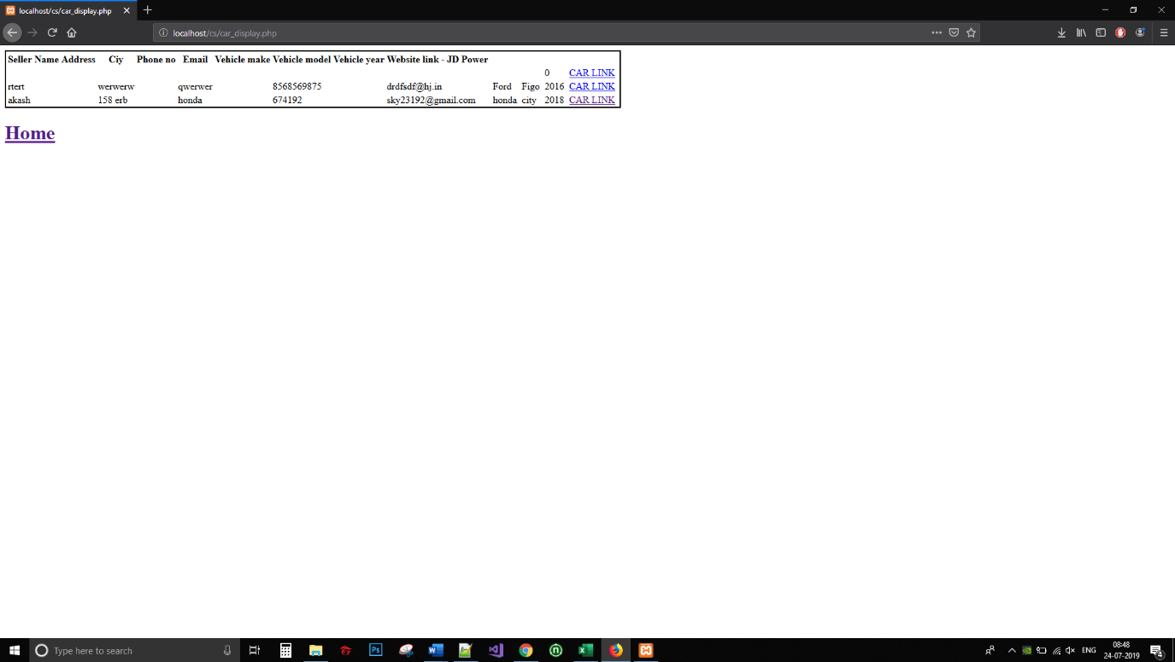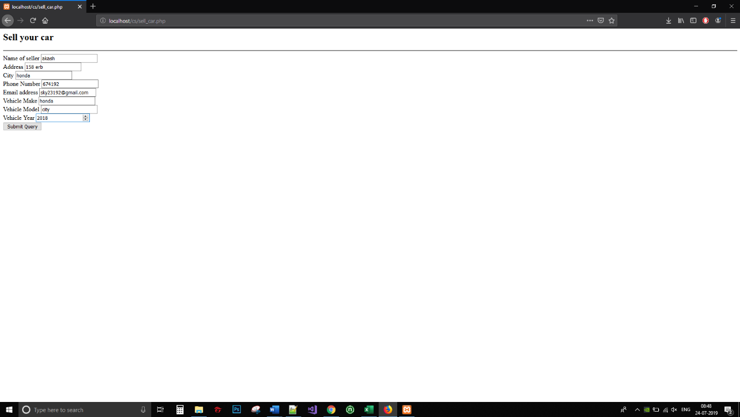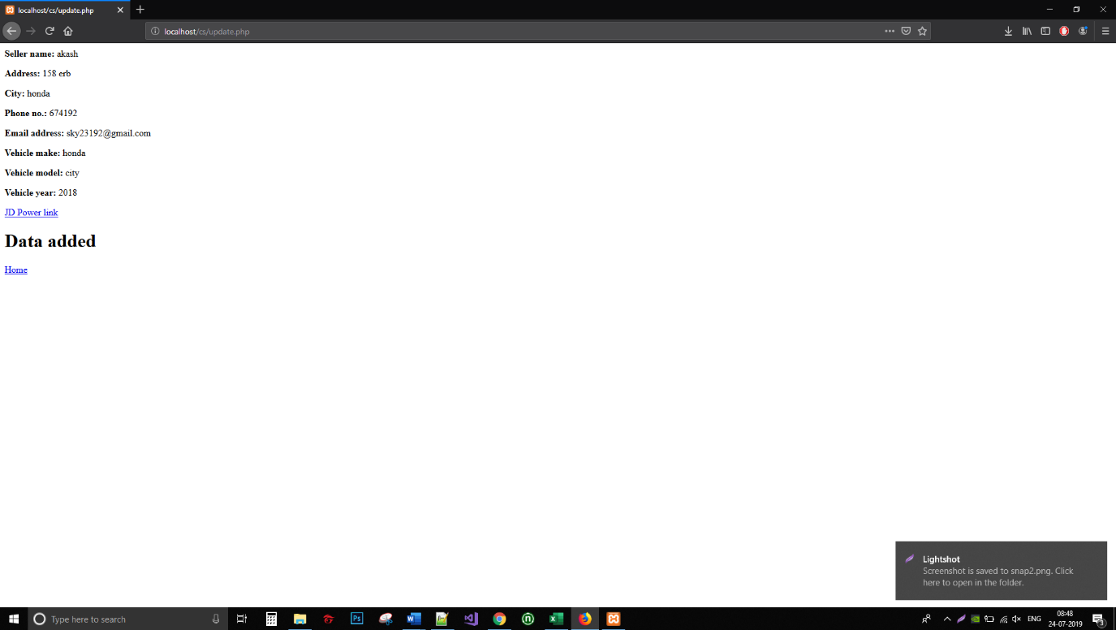

**CAR_DISPLAY.PHP**

<?php

include('database.php');

?>

<html>

<head>

</head>

<body>

<?php

$q_sql = 'select * from car_data';

$result = mysqli_query($conn, $q_sql);

$str="";

if (mysqli_num_rows($result) > 0)

{

while($row = mysqli_fetch_row($result))

{

$str.="

<tr>

<td> ".$row[0]."<td>

<td> ".$row[1]."<td>

<td> ".$row[2]."<td>

<td> ".$row[3]."<td>

<td> ".$row[4]."<td>

<td> ".$row[5]."<td>

<td> ".$row[6]."<td>

<td> ".$row[7]."<td>

<td><a href='".$row[8]."'>CAR LINK</a><td>

</tr>";

}

}

echo '

<table style="border:2px solid black">

<thead>

<tr>

<th>Seller Name</th>

<th>Address</th>

<th>Ciy</th>

<th>Phone no</th>

<th>Email</th>

<th>Vehicle make</th>

<th>Vehicle model</th>

<th>Vehicle year</th>

<th>Website link - JD Power</th>

</tr>

</thead>

<tbody>

'.$str.'

</tbody>

</table>

';

?>

<h1><a href="index.php">Home</a></h1>

</body>

</html>

**DATABASE.PHP**  
<?php

$servername = "localhost";

$username = "root";

$password = "";

$dbname = "cs_website";

$conn = mysqli_connect($servername, $username, $password, $dbname);

?>  
  
INDEX.PHP  
  
<html>

<head>

</head>

<body>

<a href="sell_car.php">

<h5>Sell Car</h5>

</a>

<a href="car_display.php">

<h5>Buy a car</h5>

</a>

</body>

</html>

SELL_CAR.PHP

<html>

<head>

</head>

<body>

<h2>Sell your car</h2>

<hr>

<form action="update.php" method="post">

<label>Name of seller</label>

<input type="text" id="sname" name="sname">

<br>

<label>Address</label>

<input type="text" id="add" name="add">

<br>

<label>City</label>

<input type="text" id="city" name="city">

<br>

<label>Phone Number</label>

<input type="text" id="phno" name="phno">

<br>

<label>Email address</label>

<input type="email" id="email" name="email">

<br>

<label>Vehicle Make</label>

<input type="text" id="v_make" name="v_make">

<br>

<label>Vehicle Model</label>

<input type="text" id="v_model" name="v_model">

<br>

<label>Vehicle Year</label>

<input type="number" id="v_year" name="v_year">

<br>

<input type="submit"/>

</form>

</div>

</div>

</div>

</body>

</html>

UPDATE.PHP

<?php

include('database.php');

?>

<html>

<head>

</head>

<body>

<?php

$jd_website_link = 'http://www.jdpower.com/cars/'.$_POST['v_make'].'/'.$_POST['v_model'].'/'.$_POST['v_year'];

echo '

<p><b>Seller name: </b>'.$_POST['sname'].'</p>

<p><b>Address: </b>'.$_POST['add'].'</p>

<p><b>City: </b>'.$_POST['city'].'</p>

<p><b>Phone no.: </b>'.$_POST['phno'].'</p>

<p><b>Email address: </b>'.$_POST['email'].'</p>

<p><b>Vehicle make: </b>'.$_POST['v_make'].'</p>

<p><b>Vehicle model: </b>'.$_POST['v_model'].'</p>

<p><b>Vehicle year: </b>'.$_POST['v_year'].'</p>

<p><a href="'.$jd_website_link.'" target="_blank">JD Power link</a></p>

';

$sql_q = 'insert into car_data values("'.$_POST['sname'].'","'.$_POST['add'].'","'.$_POST['city'].'","'.$_POST['phno'].'","'.$_POST['email'].'","'.$_POST['v_make'].'","'.$_POST['v_model'].'","'.$_POST['v_year'].'","'.$jd_website_link.'")';

if (mysqli_query($conn, $sql_q)) {

echo "<h1>Data added</h1>";

echo "<a href='index.php'>Home</a>";

} else {

echo "Error: " . $sql . "<br>" . mysqli_error($conn);

}

mysqli_close($conn);

?>

</body>

</html>